*Note : Since could not get the data of Oman , so I analysed the data of Armenia .*

1. **DECADE WISE GROWTH RATE**

Growth rate refers to the percentage change of a specific variable within a specified time interval. In this section, we will calculate the decade wise growth of Armenia’s GPD, passengers carried by railway and air transport, goods carried by Railways , per capita GDP and CO2 emission.

The formula used here to calculate the growth rate is:

$Growth rate=\left(\frac{Present Value}{Past Value}-1\right)*100\%$… (Eq. 1.1)

* Growth rate of GDP

Table 1.1 shows the GDP of growth rate of Armenia :

|  |  |
| --- | --- |
| **DECADE** | **GROWTH RATE IN %** |
| 1991-2000 | -7.648135 |
| 2001-2010 | 337.121794 |
| 2011-2020 | 24.68271 |

Table 1.1. Decade wise growth rate of GDP

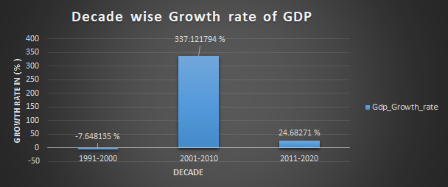

Graph : Decade wise growth rate of GDP

* Growth Rate of passengers carried by railways

Table 1.2 :

|  |  |
| --- | --- |
| **DECADE** | **GROWTH RATE IN %** |
| 1991-2000 | -45.238095 |
| 2001-2010 | -25.531915 |
| 2011-2020 | -100 |

Table 1.2 Decade wise growth rate of railway passengers carried

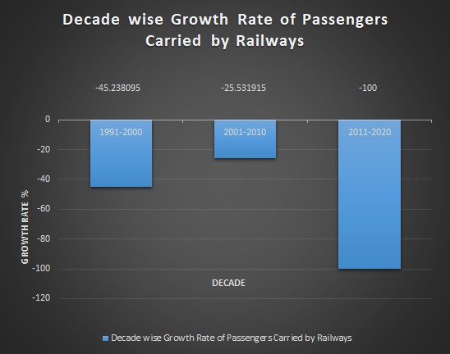

Graph : Decade wise growth rate of passengers carried by railways

* Growth rate of passengers carried by air transport

Table 1.3 :

|  |  |
| --- | --- |
| **DECADE** | **GROWTH RATE IN %** |
| 1991-2000 | -4.188774 |
| 2001-2010 | 119.064353 |
| 2011-2020 | -72.519734 |

Table 1.3 Decade wise growth rate of passengers carried by air transport

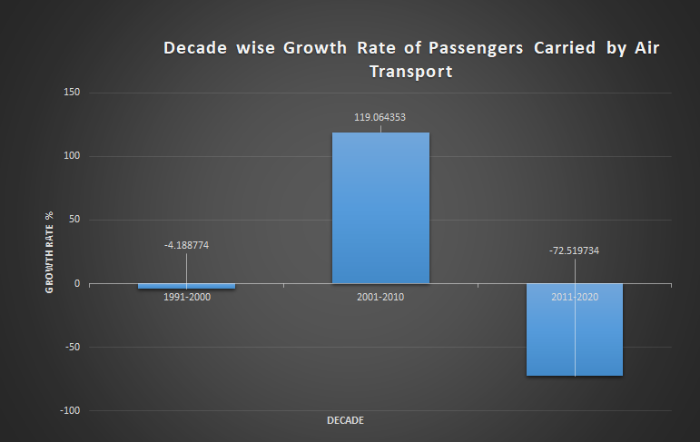

Graph : Decade wise growth rate of passengers carried by Air Transport.

* Growth rate of goods carried by Railways

Table 1.4 :

|  |  |
| --- | --- |
| **DECADE** | **GROWTH RATE IN %** |
| 1991-2000 | -15.223097 |
| 2001-2010 | 102.824858757062 |
| 2011-2020 | -100 |

Table 1.4 Decade wise growth rate of goods transported by railways

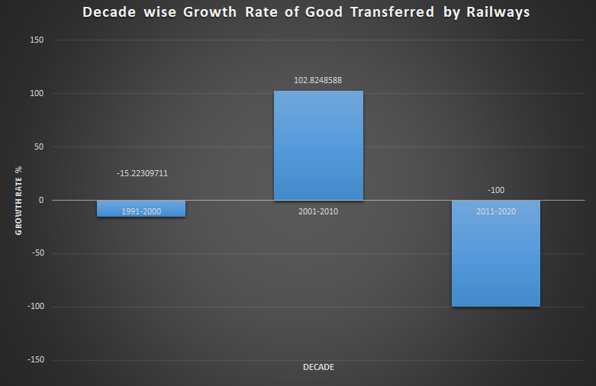

Graph : Decade wise growth rate of goods carried by Railway

* Growth rate of per capita CO2 emission

Table 1.5:

|  |  |
| --- | --- |
| **DECADE** | **GROWTH RATE IN %** |
| 1991-2000 | 5.45888680061763 |
| 2001-2010 | 363.460482789447 |
| 2011-2020 | 21.0347554290743 |

Table 1.5 Decade wise growth rate of per capita CO2 emission

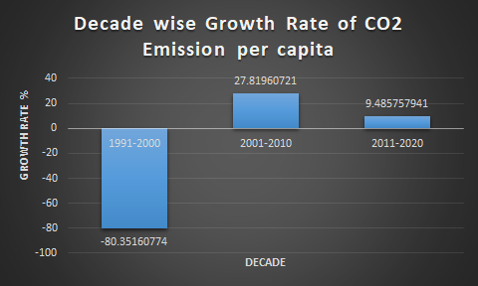

Graph : Decade wise growth rate of CO2 emission per capita

* Growth rate of per capita GDP (current US$)

Table 1.6 :

|  |  |
| --- | --- |
| **DECADE** | **GROWTH RATE IN %** |
| 1991-2000 | -80.3516 |
| 2001-2010 | 27.81966 |
| 2011-2020 | 9.485756 |

Table 1.7 Decade wise growth rate of per capita GDP (current US$)

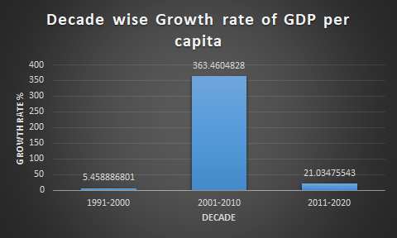

Graph : Decade wise growth rate of GDP per capita

1. **PROJECTING TREND FOR THE NEXT TWO DECADE**

There are many methods to project a trend for the following years. But in this report, the method used is the Exponential Triple Smoothing (ETS) algorithm, which comes pre-installed in MS-Excel. Here, the data for the next two decades is forecasted using the same method and is represented in a graph.

* GDP (Current US$)

Graph : predicted value of next two decade

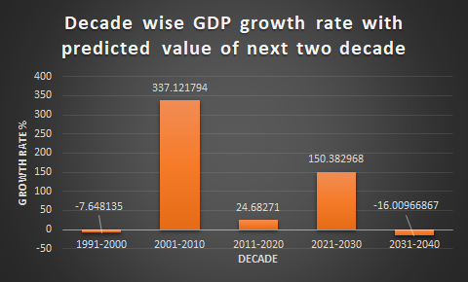

Graph : Decade wise growth rate of GDP

* Passengers carried by railways

Graph : predicted value for next two year

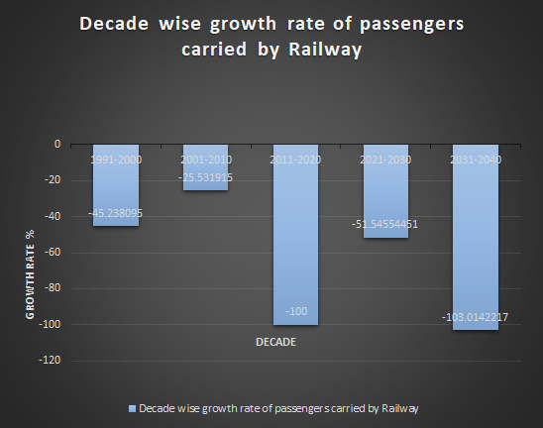

Graph 2.2 Decade wise growth rate of passengers carried by railways

* Passengers carried by air transport

Graph : Predicted value for the next two decade

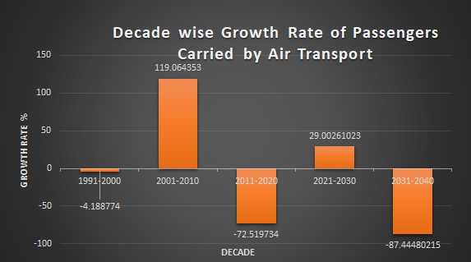

Graph 2.3 Decade wise growth rate of passengers carried by air transport

* Goods Transported by Railways

Graph : Predicted value of the next two decade

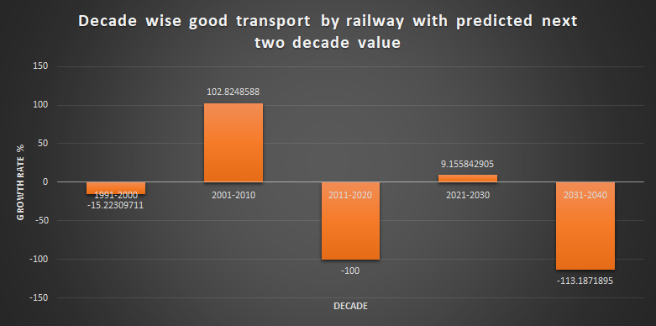

Graph 2.4 Decade wise Growth Rate of goods transported by railways

* Per capita CO2 Emission

. Graph : Predicted value of the next two decade

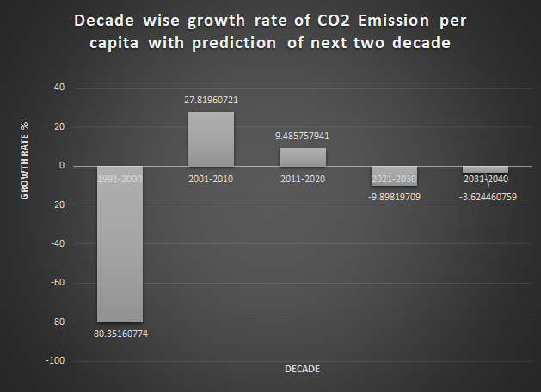

Graph 2.5 Decade wise growth rate of per capita CO2 emission

* Per capita GDP

Graph : Predicted value for the next two decade

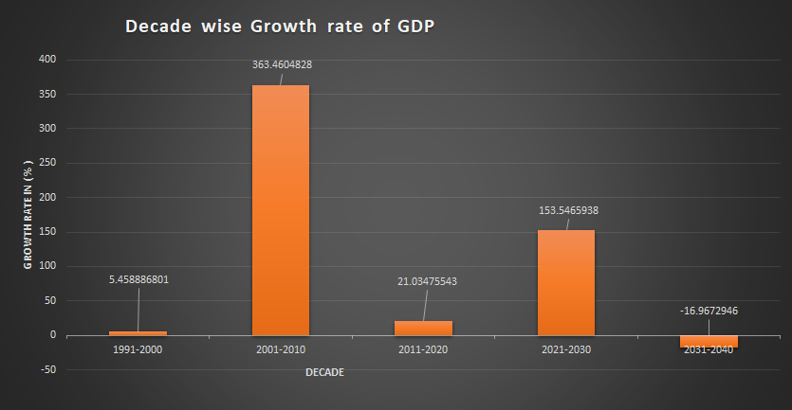

Graph 2.6 Decade wise growth rate of per capita GDP

1. **RELATIONSHIP BETWEEN PER CAPITA GDP AND PER CAPITA CO2 EMISSION**

Graph 3.1 plots a scatter graph for per capita CO2 emission vs. per capita GDP. A linear trendline is drawn which shows the correlation of the two factors. It can be seen that as per capita GDP increases, per capita CO2 emission also increases. From the correlation-squared value, they are not perfectly related. The R-value is calculated to be 0.3011 which shows weak association between the 2 data.

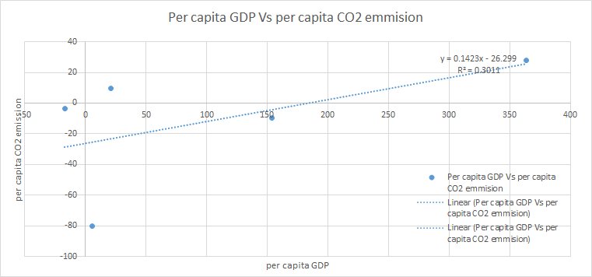

Graph 3.1 Relationship between per capita GDP and per capita CO2 Emission

1. **RELATIONSHIP BETWEEN PER CAPITA GDP AND PASSENGERS CARRIED BY RAILWAY**

Graph 4.1 shows the scatter plot for the given data. R-value is calculated to be 0.5591 which shows positive association, which means most of the values for passengers carried by railways increases when the per capita GDP value increases. R-squared value also gives good relation.

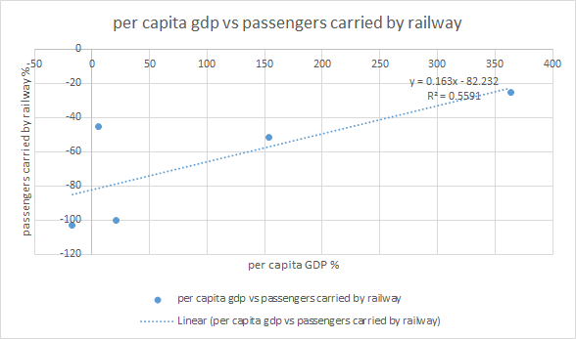

Graph 4.1 Relationship between per capita GDP and passengers carried by railways

1. **RELATIONSHIP BETWEEN PER CAPITA GDP AND PASSENGERS CARRIED BY AIR TRANSPORT**

Graph 5.1 shows the relationship between the two factors by using a scatter plot. R-value is 0.8649 which shows moderate positive correlation between per capita GDP and passengers carried by air transport.

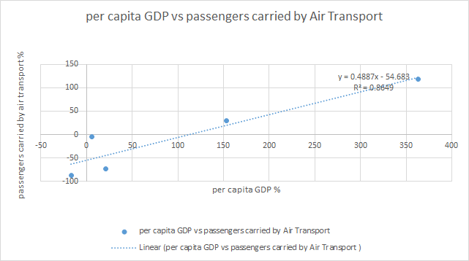

Graph 5.1 Relationship between per capita GDP and passengers carried by air transport